**OUTREACH SCHOOLS EXAMINATION BOARD**

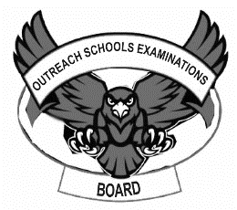 **BEGINNING OF TERM III EXAMINATION 2024**

**PRIMARY ONE**

**LITERACY 1A**

**My name is ___________________________________________**

**I am in ________________________________________________**

**My school is __________________________________________**

1. **Fill in the missing letters.**
2. c ___ w.
3. wat ___ r.
4. so ___ p.
5. b ____ rd.
6. Living things are things which have __________________________________.
7. Name these living things.

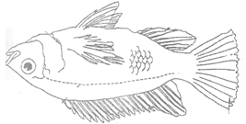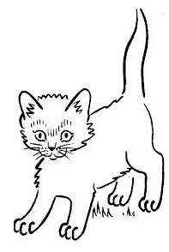

1. Write down two things living things can do.
   1. Living things can ____________________________________
   2. Living things can ___________________________________
2. **Circle the non- living things.**

**car cat cup chair cow.**

1. 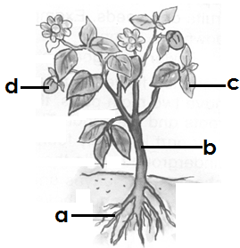Name the parts.

**a**.________________________

**b**.________________________

**c**.________________________

**d**.________________________

**(stem roots fruit leaf)**

1. Give any two uses of plants to people.

**a.** People get __________________________from some plants.

**b**. People get __________________________from some plants.

**(fruits beef snakes flowers)**

1. **Draw and name any two domestic animals.**
2. Write the mothers to these young ones.

**lamb - sheep**

1. calf_______________________**b**.piglet _______________________

**c.**fry_________________________**d**. kitten_______________________

1. **Match correctly**

tongue walking

eyes hearing

legs smelling

nose tasting

ear seeing

1. How do people keep the body clean? Give one way.

people keep the body clean by____________________________

1. Draw these things people use to keep the body clean.

**razorblade**

**comb**

**toothbrush**

1. Tick (√) the common diseases.

**flu sharp cough clothes**

1. 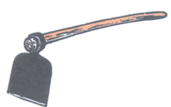**a**. Name this tool we use to clean the school.

This is a ___________________________

It is for ____________________________

**b**. Name the tool we use to collect rubbish

___________________________________

1. Name these common accidents.

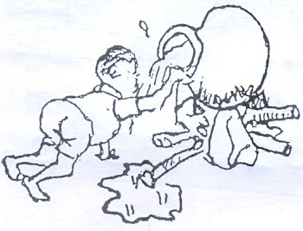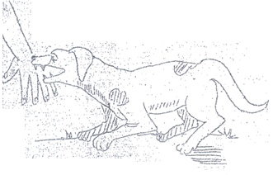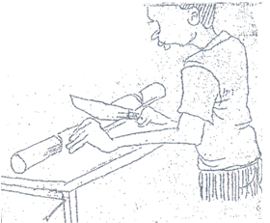

**(poisoning, bites, burns, cuts)**

1. Why do we give First Aid? Give one reason.

We give First Aid to ___________________________________life.

**(bring, save, give)**

1. Name this food that we eat.

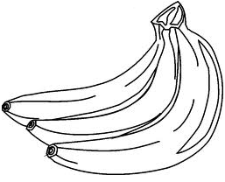



1. Name the food kept safe by the following ways.

a. smoking_________________________________________________

b. sun drying _______________________________________________

1. 
2. This is a __________________________________________________
3. It lives in ________________________________________________
4. It uses_____________________________to respire.

***Good Luck***